Erin Brenner
978-996-0389
erin@righttouchediting.com
www.righttouchediting.com

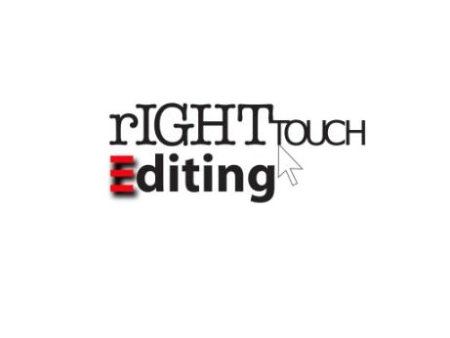

Experience

Communications Professional Sept. 2005–present
Right Touch Editing, Haverhill, MA
- Write and edit client copy; clients include Collins Education Associates, Harvard Graduate School of Education, and BarCharts
- Manage publishing projects for clients
- Train communications professionals in writing, editing, and related topics
- Speak at industry-related live events

CEO Sept. 2015–Nov. 2018
Pilcrow Group, LLC, Durham, NC
- Led company, setting strategy and goals
- Co-managed the Copyediting brand
- Oversaw Copyediting’s publications and led training courses
- Co-authored Copyediting’s Grammar Tune-Up Workbook

Copy Chief & Associate Editor Oct. 2000–Oct. 2009
Incisive Media, New York, NY
- Copyedited, fact-checked, and coded columns, tables, and marketing materials for ClickZ.com
- Wrote, edited, and distributed writer newsletter
- Acted as daily contact for readers and freelancers
- Assisted Executive Editor with day-to-day site operations

Research Editor/Project Editor Feb. 1999–Oct. 2000
IDC, Framingham, MA
- Copyedited and fact-checked high-tech marketing research and special projects
- Prepared graphics for production
- Kept current filing information for subscription research

Proofreader June 1994–Feb. 1999
Epsilon Data Management, Burlington, MA
- Proofread direct mail projects
- Organized and maintained all client specifications in department style manual

Professional Organizations
- VP of Communications, American Marketing Association, Boston chapter
- Advanced Professional Member of the Society for Editors and Proofreaders
- Member of ACES: The Society for Editing

Education
- MA in English, Northeastern University
- BA in English, Salem State University

